Class Test
Date – 2/12 /2025
Ch -14 and 15
FM -15
.
Q1. Assertion (A): Respiration is a process in which living beings take in oxygen and give out carbon dioxide.
Reason (R): Oxygen is used to produce energy in the body, and carbon dioxide is released as a waste product.
a) Both A and R are true, and R is the correct explanation of A.
b) Both A and R are true, but R is not the correct explanation of A.
c) A is true but R is false.
d) A is false but R is true.
Q2. Assertion (A): Cyclone Amphan occurred earlier than Cyclone Yaas.
Reason (R): Cyclone Amphan took place in 2020, while Cyclone Yaas occurred in 2021
a) Both A and R are true, and R is the correct explanation of A.
b) Both A and R are true, but R is not the correct explanation of A.
c) A is true but R is false.
d) A is false but R is true.
Q3. a cold morning, you breathe out near your hands and then onto a glass surface. In which situations might this warm breath help you do something useful? ( Any 2 point )
Q4.Name any two agencies that can help during a disaster.( 2 )
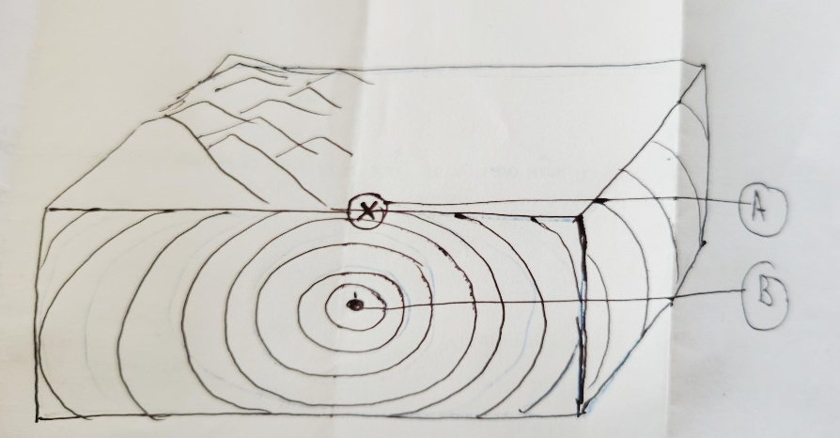
Q5 Define Respiration . Draw and label a diagram of Human Respiratory system .(1+4)
Q6. Identify A and B write their names also define them . ( 2+2 )

